SYRINGE LABELLING IN CRITICAL CARE AREAS
AIM: To simplifies medication recognition, assigning unique colours to different drug types. This streamlined process significantly reduces medication error risks by visually distinguishing medications which in turn enhances patient safety and boosts healthcare staff confidence.
PATIENT: This local operating policy applies to all inpatients stay in critical care.
STAFF: All health care professionals who prepare and/or administer injectable medicines.
General Principles: Injectable medications prepared in syringes must adhere to correct labelling using the standardised colour-coded labels, as illustrated below. These labels must be correctly labelled to include information such as the medication type, dosage, volume, diluent, patient's name, an additional patient identifier (e.g., hospital number or date of birth), ward, preparation date and time, expiration date, the name of the individual who prepared it, and the name of the person responsible for verification.
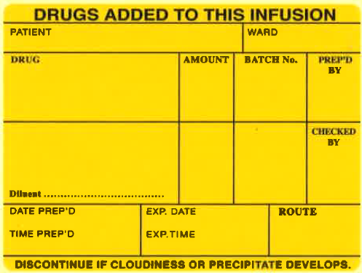
SYRINGE LABELS
SEDATION / INDUCTION (YELLOW)
- PROPOFOL
- KETAMINE
- ETOMIDATE
- THIOPENTAL

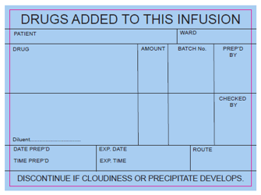
OPIOIDS (BLUE)
- FENTANYL
- ALFENTANIL
- MORPHINE
- REMIFENTANIL
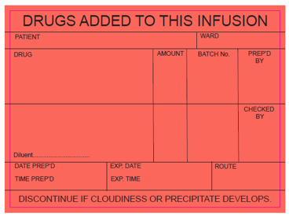
MUSCLE RELAXANTS (WARM RED)
- CISATRACURIUM
- ATRACURIUM
- ATRACURIUM

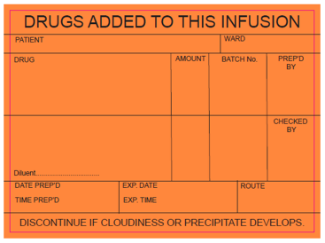
BENZODIAZEPINES (ORANGE)
- MIDAZOLAM
- DIAZEPAM

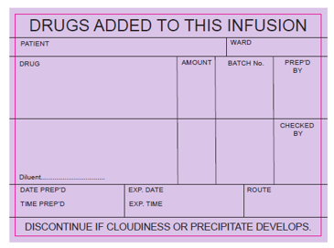
VASOPRESSORS (Purple)
- METARAMINOL
- PHENYLEPHRINE
- NORADRENALINE
- ADRENALINE
- EPHEDRINE
- VASOPRESSIN
- DOBUTAMINE

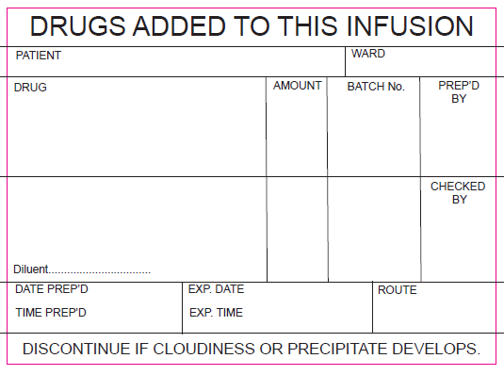
OTHER DRUGS (WHITE)
- ANTIBIOTICS
- POTASSIUM
- ACTRAPID
- HEPARIN
etc

How to order labels: You can order these labels as ward stock from the pharmacy, as demonstrated in the example below.
Types of labels | How to write the requisition | Quantity
Sedation/induction agents | Drugs added labels - Yellow | 1 roll =1000 labels
Opioids | Drugs added labels - Blue
Muscle relaxants | Drugs added labels - Red
Benzodiazepines | Drugs added labels - Orange
Vasopressors | Drugs added labels - Purple
Others | Drugs added labels - White

